**Ideation Phase**

**Brainstorm & Idea Prioritization**

| Date | 16 February 2026 |
| --- | --- |
| Team ID | LTVIP2026TMIDS88973 |
| Project Name | Civil Engineering Insight Studio |
| Maximum Marks | 4 Marks |

**Brainstorm & Idea Prioritization Template:**

**Short Note — Brainstorm & Idea Prioritization**

Brainstorming helps identify how the Civil Engineering Insight Studio can enhance travel planning through intelligent technology. Many travelers face challenges in creating trips that fit their interests, budget, and time due to scattered information and lack of personalization. To address this, the proposed AI-based system automatically generates personalized travel itineraries.

Users enter their preferences such as destination, budget, travel duration, and interests. The AI analyzes this input and recommends suitable places, activities, hotels, and optimized travel schedules. By providing smart suggestions and efficient route planning, the system reduces planning time, improves travel efficiency, and delivers a more satisfying and customized travel experience.

**Step-1: Team Gathering, Collaboration and Select the Problem Statement**

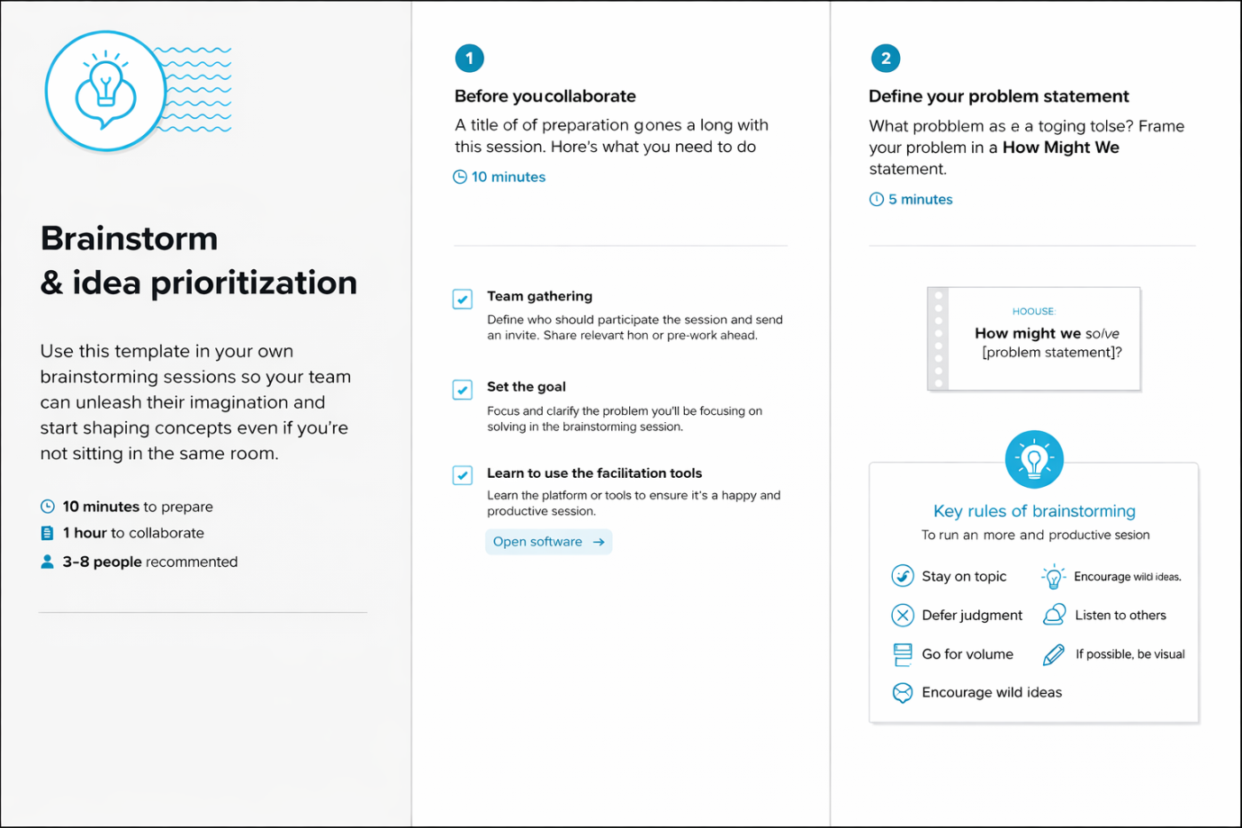

**Step-2: Brainstorm, Idea Listing and Grouping**

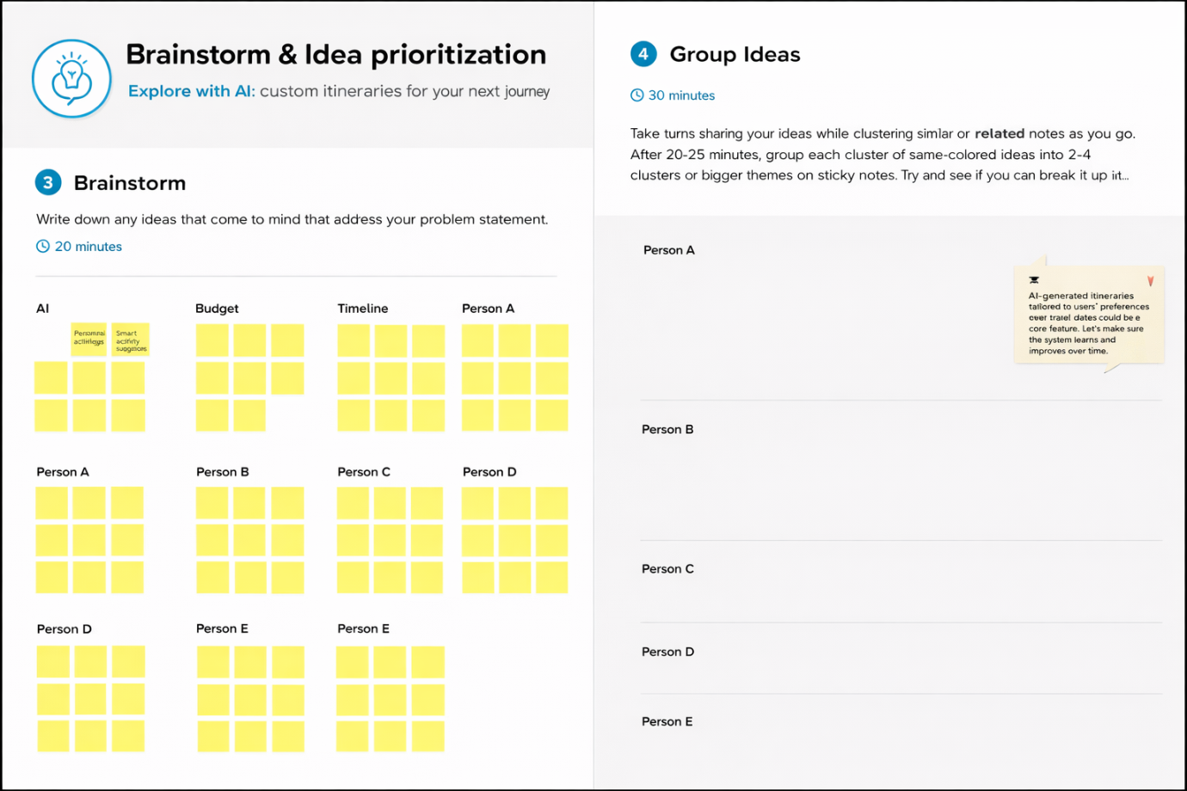

**Step-3: Idea Prioritization**

